CUSTOMISE SWITCH WITH NETWORK MODULES USING CISCO PACKET TRACER
EXPT: 11
AIM:
To enhance a switch by integrating additional network modules in Cisco Packet Tracer and confirm the improved connectivity capabilities.
INTRODUCTION:
Cisco devices support hardware customization through modular components known as network modules. These pluggable modules allow users to expand device functionality without replacing the entire hardware.
By installing suitable modules, we can:
- Extend the number of Ethernet or Gigabit Ethernet ports.
- Include fiber optic, FastEthernet, or serial interfaces.
- Enable new connectivity features such as WAN or wireless links.
Cisco Packet Tracer provides a virtual platform to perform these customizations, letting us simulate real device upgrades for learning and testing purposes.
PROCEDURE / ALGORITHM:
- Launch Cisco Packet Tracer and add a Switch to the workspace.
- Switch to the Physical tab and power off the device.
- Remove the cover plates from any unused module slots.
- Insert the desired network module (for example, NM-1E, NM-1T, etc.) into the available slot.
- Power on the switch.
- Verify that the newly added interfaces (Ethernet, FastEthernet, or GigabitEthernet) appear under the device’s configuration tab.
- Place two PCs (PC0 and PC1) in the workspace.
- Use Copper Straight-Through cables to connect the PCs to the switch’s new interfaces.
- Configure the switch interfaces:
  - Assign appropriate IP addresses.
  - Use the no shutdown command to activate each interface.
- Configure the PCs:
  - Assign IP addresses within the same subnet.
  - Set the default gateway to the switch interface’s IP address.
- Test Connectivity:
  - Ping the switch from each PC.
  - Ping between PC0 and PC1 to ensure proper communication.

TOPOLOGY:
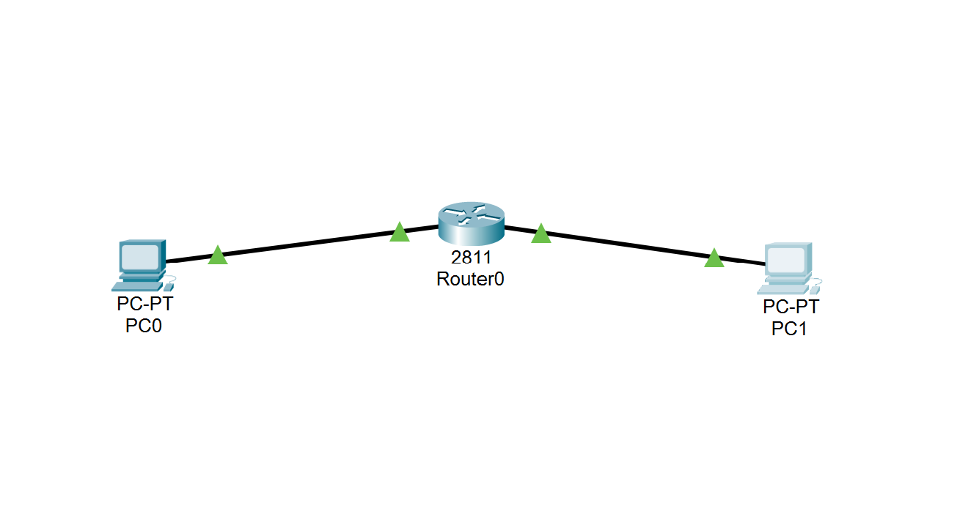
OUTPUT:
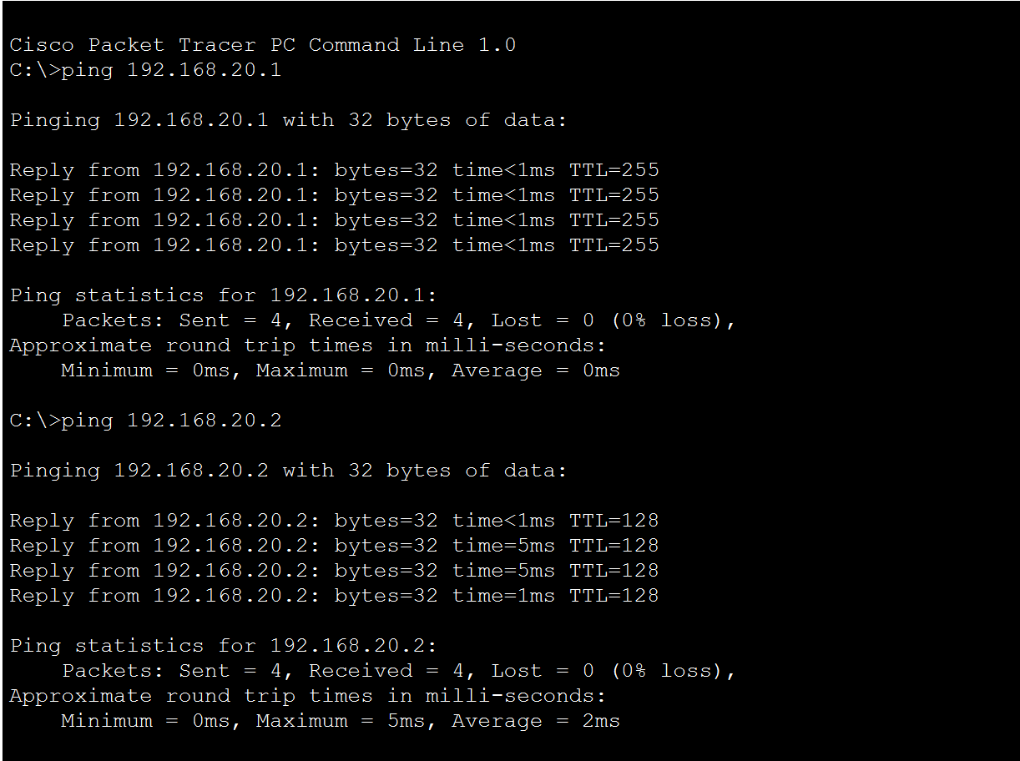

RESULT:
The switch was effectively upgraded by inserting network modules, providing additional active ports. The modified switch successfully established communication with connected PCs in Cisco Packet Tracer.

